Summary
The APP development sample contains the following parts:
- Get token
- Subscribe
- Receive AMQP message
- Unsubscribe
SVA
Get token
Subscribe
Receive AMQP message
Unsubscribe

Compile
Type make clean all in console to compile
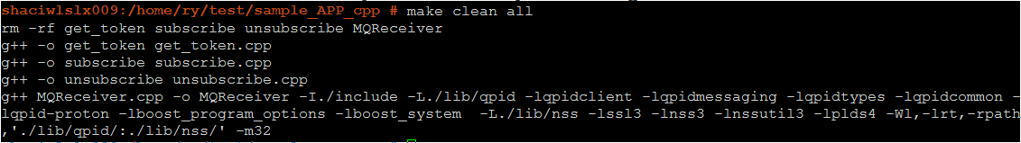
You will get the following executable files
get_token
subscribe
MQReceiver
unsubscribe

Get token
Requirement:
OS runing the sample should have curl installed
You can check by running curl in console:
Or, you can install it by reference: http://curl.haxx.se/
Usage:
./get_token ip app_name pwd
Note:
ip/app_name/pwd should coordinate with MML command ADD APP
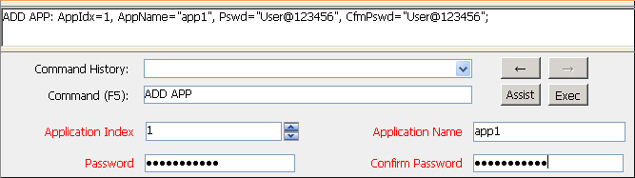
Output:
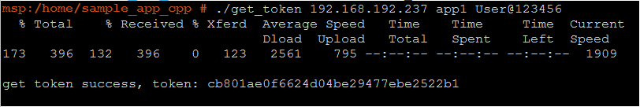

Subscribe
Requirement:
you have got a token by 2. Get token
Usage:
./subscribe ip app_name token
Output:
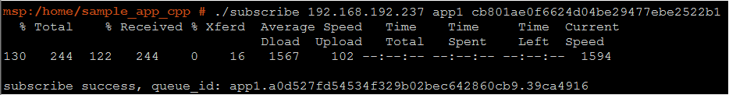
Note:
You can use optional parameter a to subscribe an anonymous topic：
./subscribe ip app_name token a

Receive AMQP message
Requirement:
- Folder cert_db and lib should be placed at the same path with MQReceiver
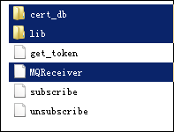
- Copy all files in folder lib/qpid/sasl2 to /usr/lib/sasl2
- you have got a queue_id by 3 Subscribe
Usage:
./MQReceiver app_name ip port queue_id
Output:
Messages in broker bound to queue_id will shown in console:
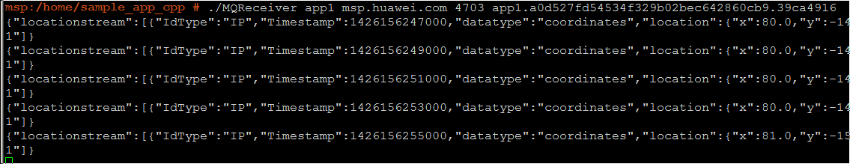
Use step 5. unsubscribe to terminate the receiver.

Unsubscribe
Requirement:
you have got a token by 2. Get token
Usage:
./unsubscribe ip app_name token
Output:
Note:
You can use optional parameter a to unsubscribe an anonymous topic：
./unsubscribe ip app_name token a

